Set 5: Website Analytics
Dataset: Website Traffic

1. Line Chart (Daily Page Views):
Procedure:
- Open Tableau.
- Connect to your Excel file.
- Open Sheet 1.
- Drag Date → Columns.
- Drag Page Views → Rows.
- In Marks, choose Line.
- Right-click Date → choose Exact Date (or Day).
- Click Show Me → Line Chart (optional).
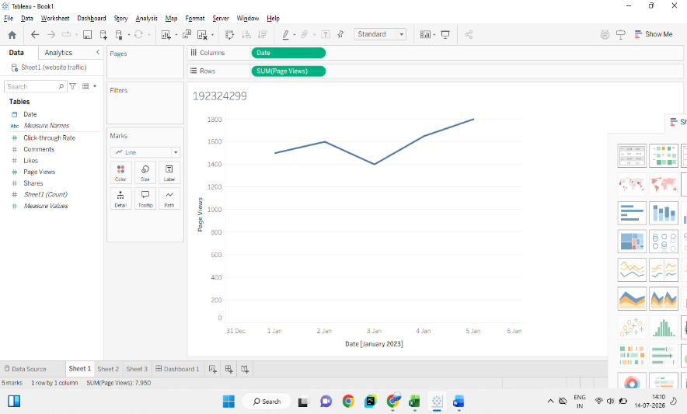

2. Bar Chart (Highest Click-Through Rates):
Procedure:
- Create Sheet 2.
- Drag Date → Columns.
- Drag Click-through Rate → Rows.
- Change Marks to Bar.
- Click the Sort Descending button.
- To show the Top N (here N = 5 since only 5 records):
- Right-click Date
- Filter
- Top tab
- Top 5 by Click-through Rate (optional with larger datasets).
- Drag Click-through Rate → Label.
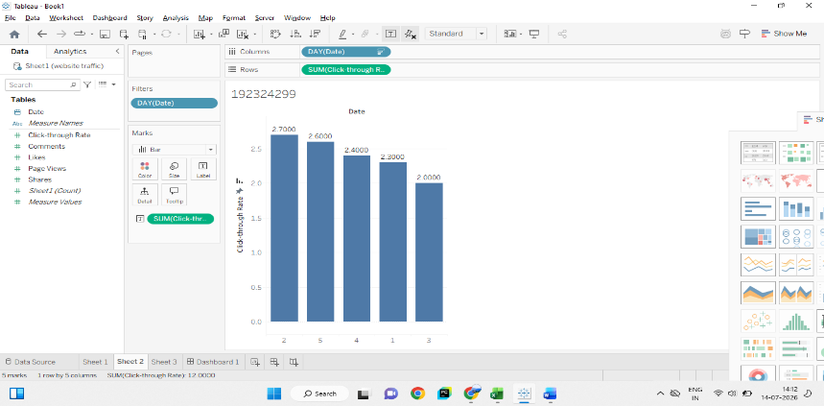

3. Stacked Area Chart
Procedure:
- Import the new data.
- Open Sheet 3.
- Drag Date → Columns.
- Select Likes, Shares, and Comments together.
- Drag them to Rows.
- Choose Show Me → Stacked Area.

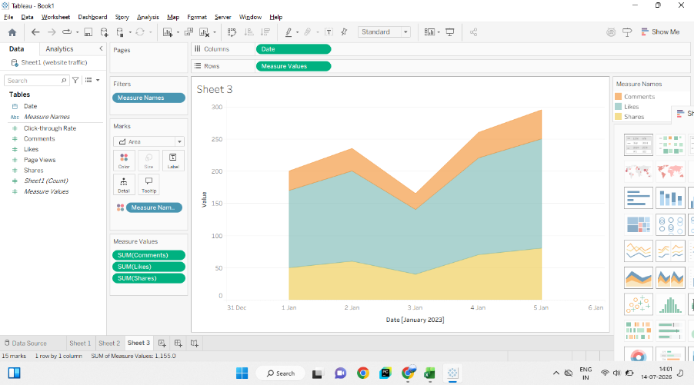

4. Dashboard
- Procedure:
- Click New Dashboard.
- Set Dashboard Size to Automatic.
- Drag the following sheets onto the dashboard:
- Daily Website Page Views
- Top Click-through Rate
- Arrange them side by side.
- Click each chart ▼ → Use as Filter.

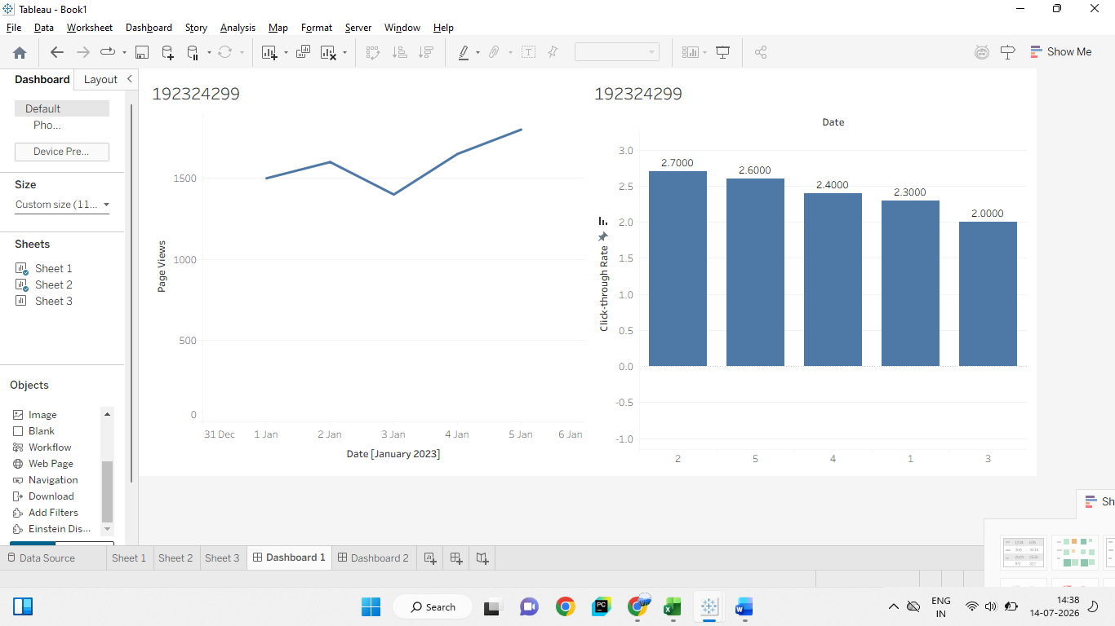

Set 6: Product Sales Analysis
Dataset: Monthly Product Sales
1. Grouped Bar Chart
Procedure:
- Connect the Excel file to Tableau.
- Open Sheet 1.
- Drag Month → Columns.
- Drag Sales → Rows.
- Drag Product Name → Colour.
- Click Show Me → Side-by-Side Bars (Grouped Bar Chart).
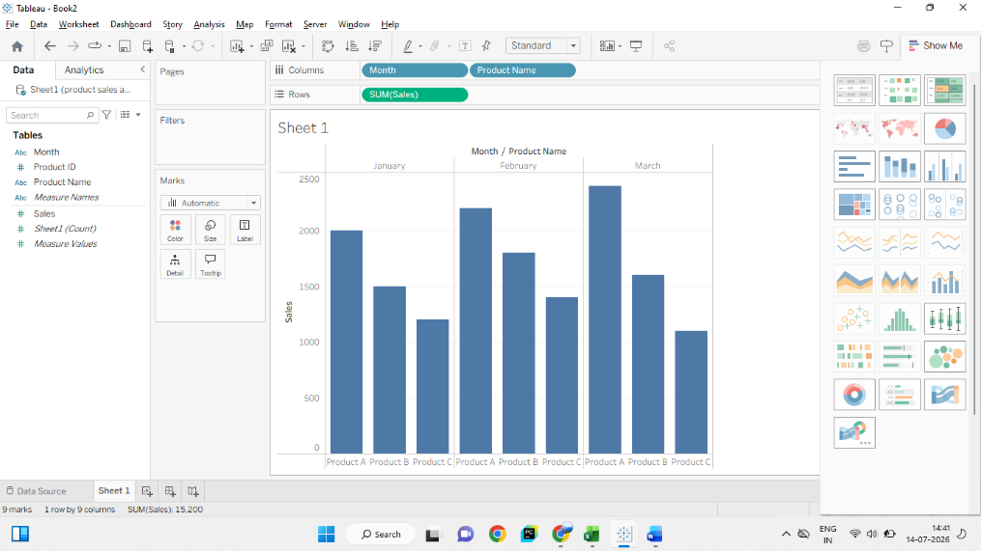

2. Stacked Area Chart
Procedure:
- Create Sheet 2.
- Drag Month → Columns.
- Drag Sales → Rows.
- Drag Product Name → Color.
- Change Marks to Area.
- Go to Analysis → Stack Marks → On.
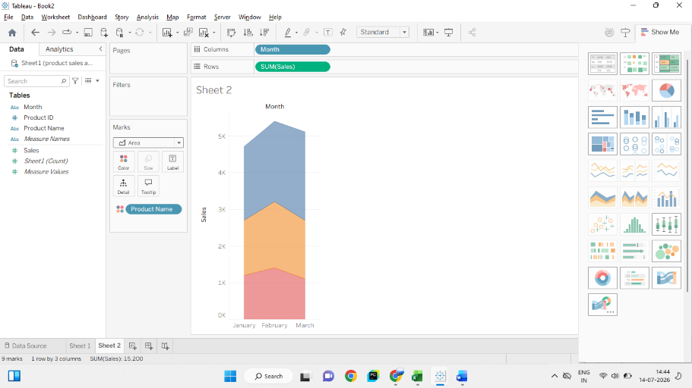

3. Table
Procedure:
- Create Sheet 3.
- Drag Product Name → Rows.
- Drag Month → Columns.
- Drag Sales → Text on the Marks card.
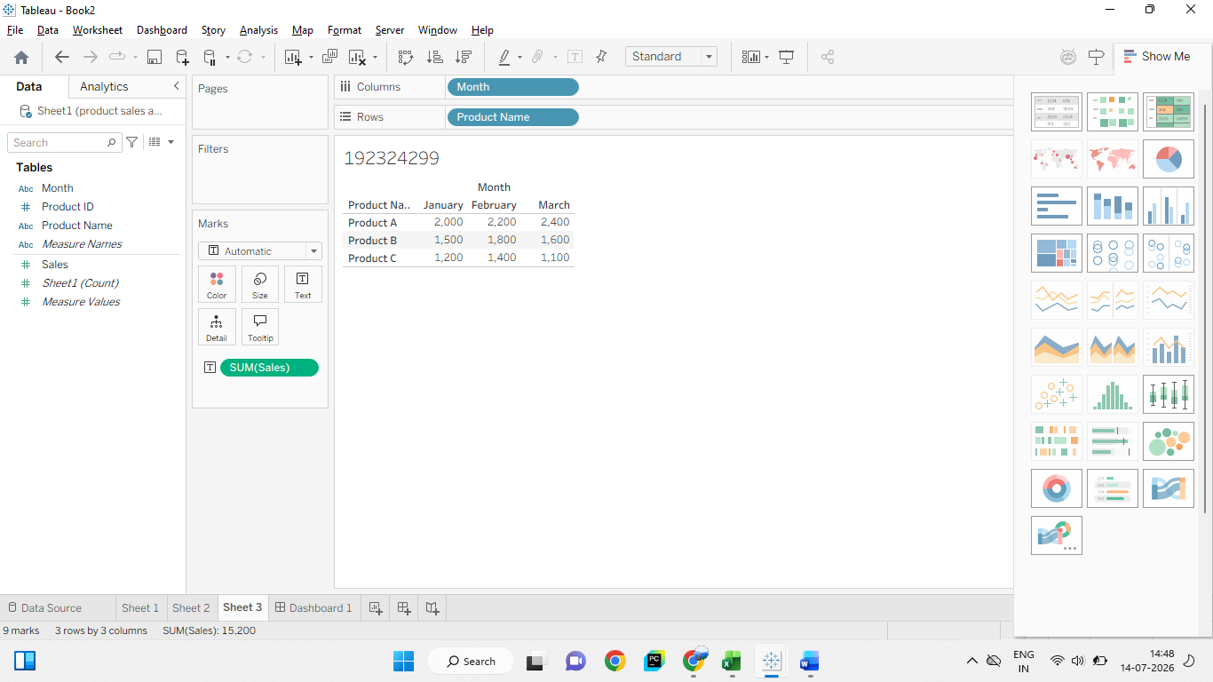

4. Dashboard
Procedure:
- Click Dashboard → New Dashboard.
- Drag:
  - Sheet 1 (Grouped Bar Chart)
  - Sheet 2 (Stacked Area Chart)
  - Sheet 3 (Table)
- Arrange them neatly (charts on top, table below).
- Click the ▼ on each chart and select Use as Filter (optional for interactivity).
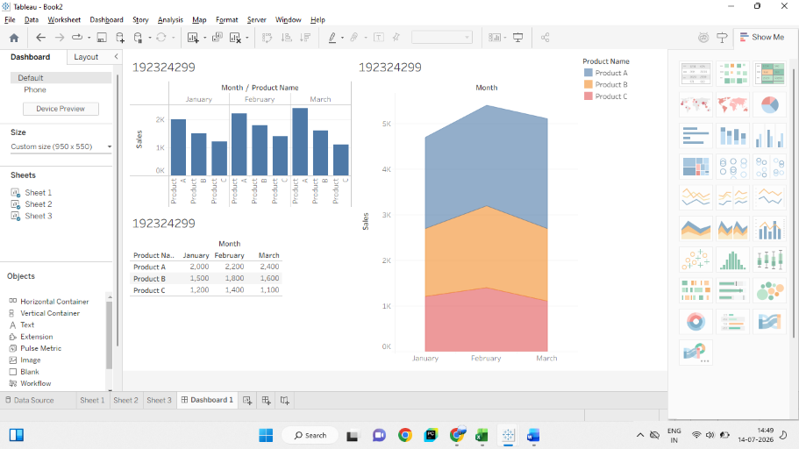

Set 7: Customer Demographics Analysis
Dataset: Customer Demographics
1. Bar Chart – Customer Ages
Procedure:
- Open Sheet 1.
- Drag Customer ID → Columns.
- Drag Age → Rows.
- Change Marks to Bar.
- Drag Age → Label (optional).

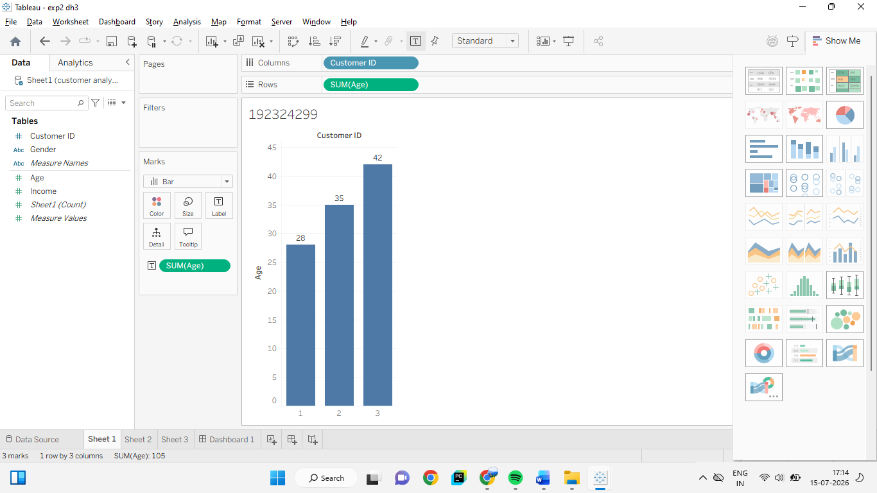

2. Pie Chart – Gender Distribution
Procedure:
- Create Sheet 2.
- Change Marks to Pie.
- Drag Gender → Color.
- Drag Gender → Label.
- Drag Customer ID → Angle.
- Right-click Customer ID → Measure → Count (or drag Number of Records to Angle, depending on your Tableau version).
- Drag COUNT(Customer ID) → Label to display the counts.

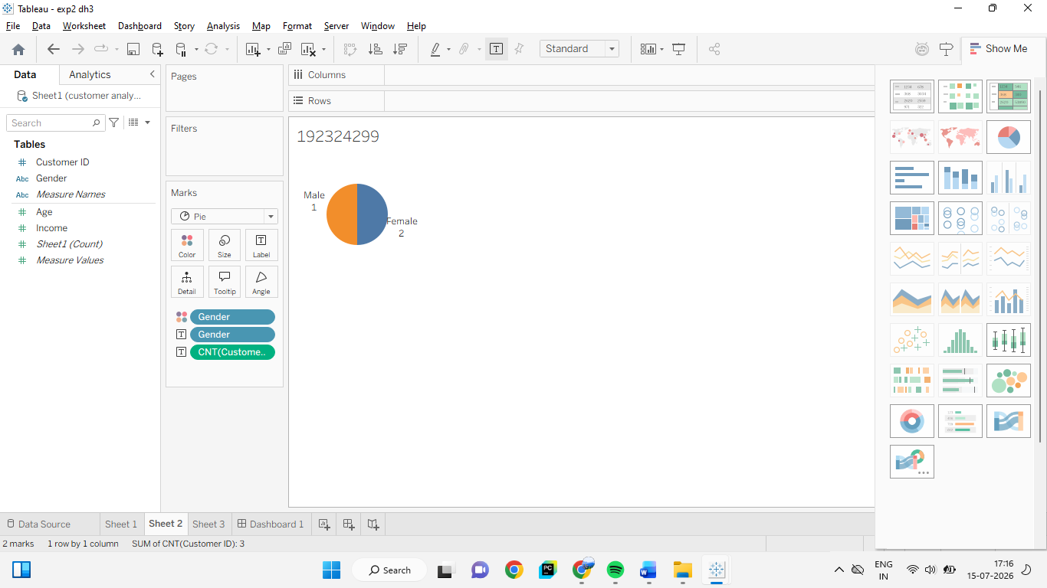

3. Table – Customer Demographics
Procedure
- Create Sheet 3.
- Drag Customer ID → Rows.
- Drag Age → Rows.
- Drag Gender → Rows.
- Drag Income → Rows.
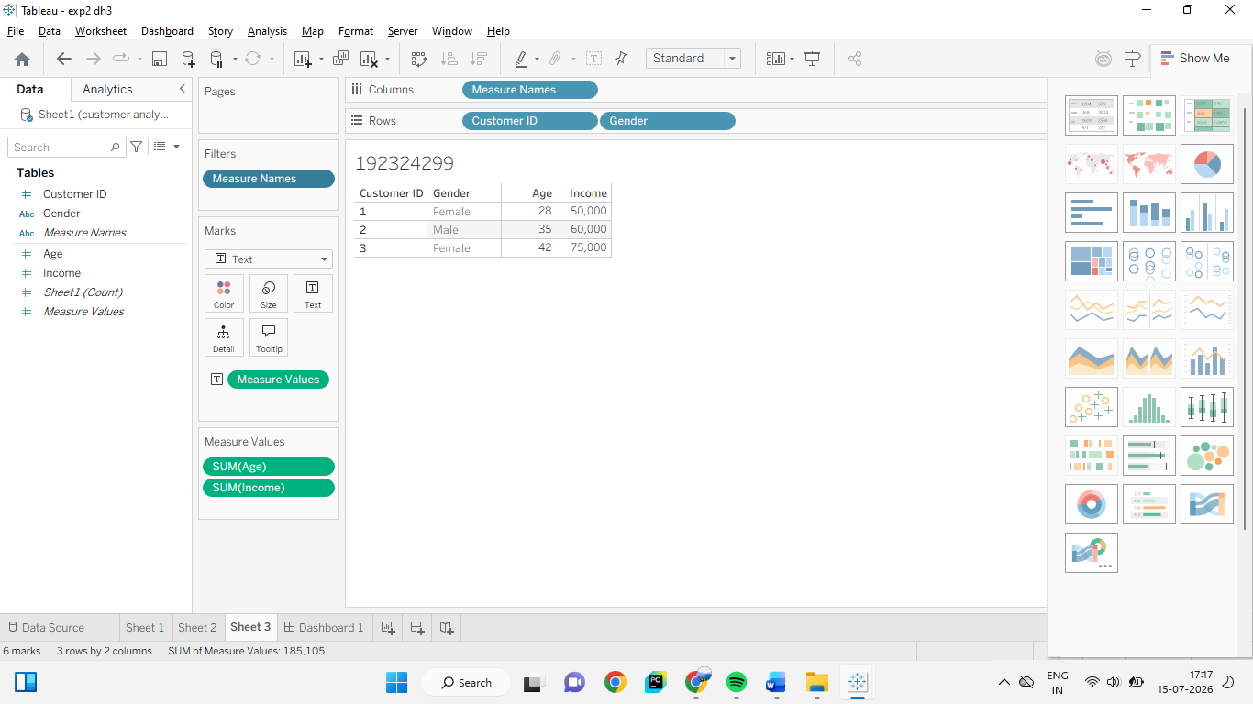

4. Dashboard
Procedure:
- Click Dashboard → New Dashboard.
- Drag:
  - Sheet 1 (Bar Chart)
  - Sheet 2 (Pie Chart)
  - Sheet 3 (Table)
